**­­**

**­­­­­­­**

**LAB # 03**

|  |  |
| --- | --- |
| **SUBMITTED TO­** | ­ **Esha E Noor Durrani** |
| **SUBMITTED BY** | **Muhammad Ayaan Farrukh** |
| **REGISTRATION NO.** | **B24F0488CS035** |

**­**

**ASSIGNMENT**

# **CODE # 1: EVEN OR ODD CHECKER**

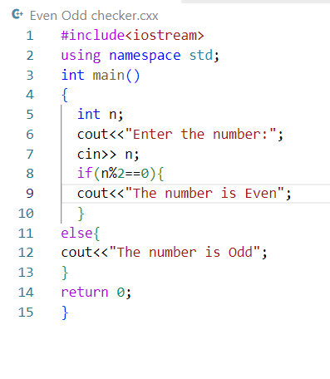**SOURCE CODE:**

**OUTPUT:**

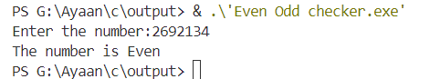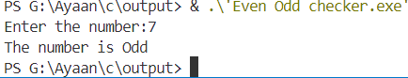

# **CODE # 2: GRADE CALCULATOR**

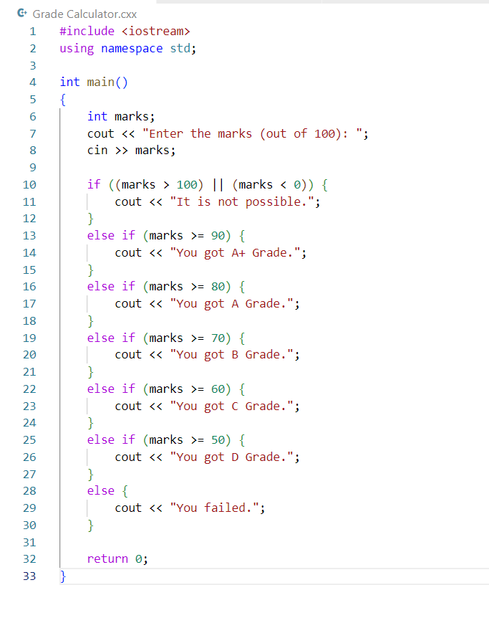

**SOURCE CODE:**

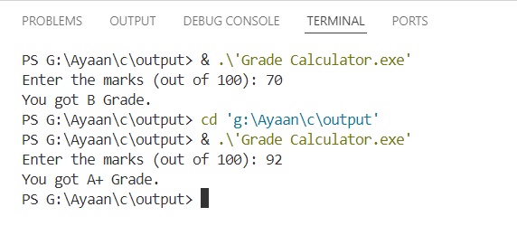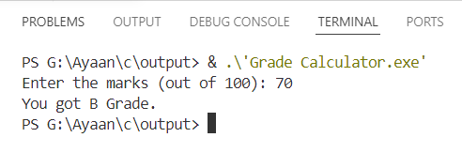**OUTPUT:**

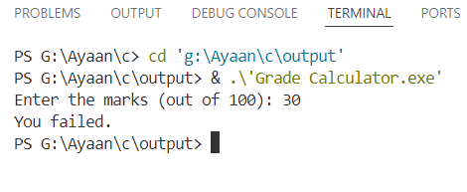

# **CODE # 3: LEAP YEAR CHECKER**

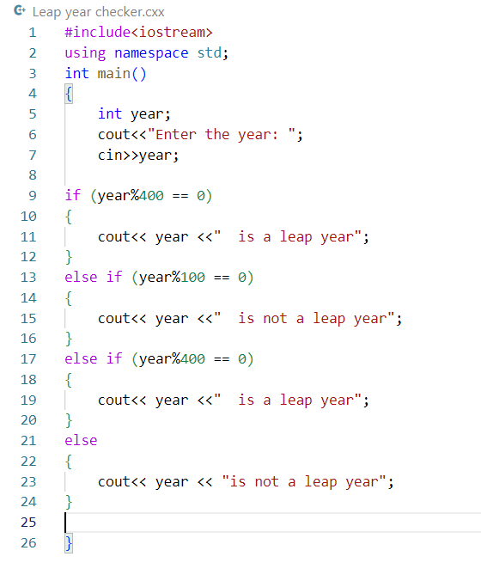**SOURCE CODE:**

**OUTPUT:**

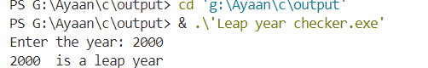

# **CODE # 4: Number Comparison**

# **SOURCE CODE**A screenshot of a computer code Description automatically generated:

**OUTPUT:**

# **CODE # 5: Vowel or Consonant Checker**

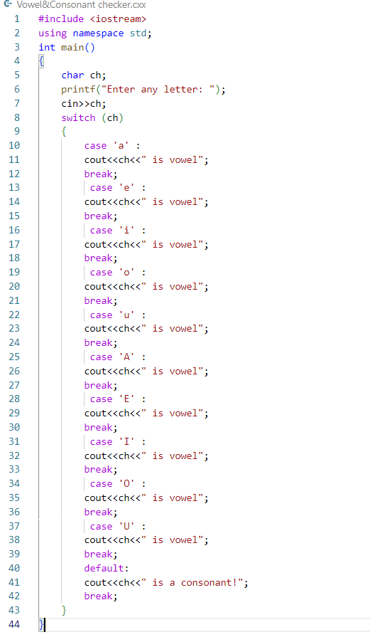

**SOURCE CODE:**

**OUTPUT:**

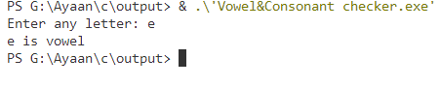

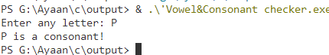

# **CODE # 6: Simple Calculator**

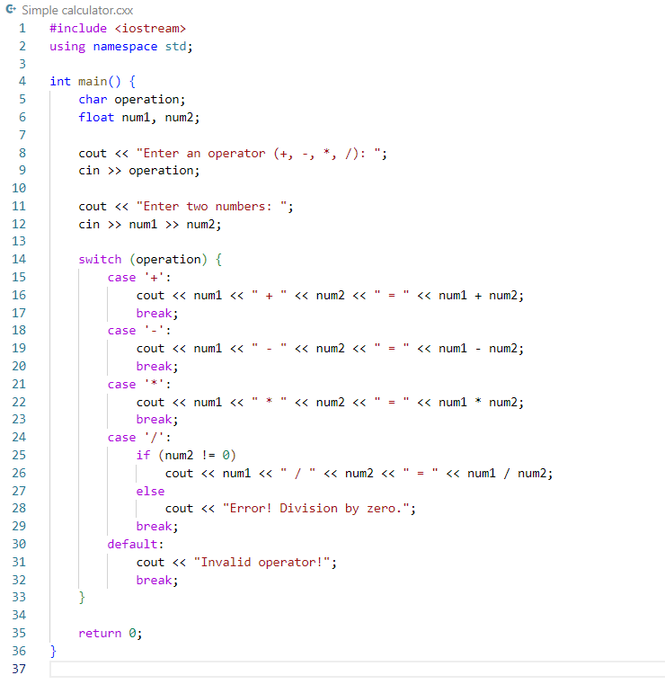**SOURCE CODE:**

**OUTPUT:**

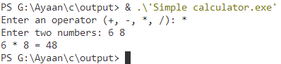

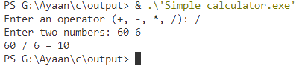

# **CODE # 7: Positive, Negative, or Zero**

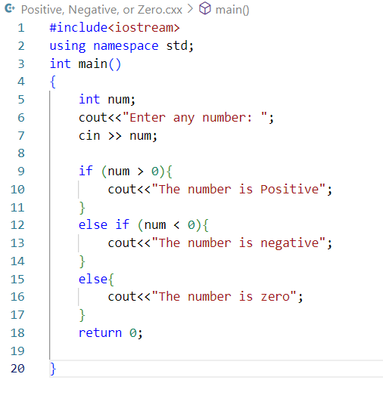**SOURCE CODE:**

**OUTPUT:**

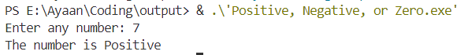

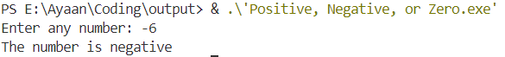

# **CODE # 8: Password Validator**

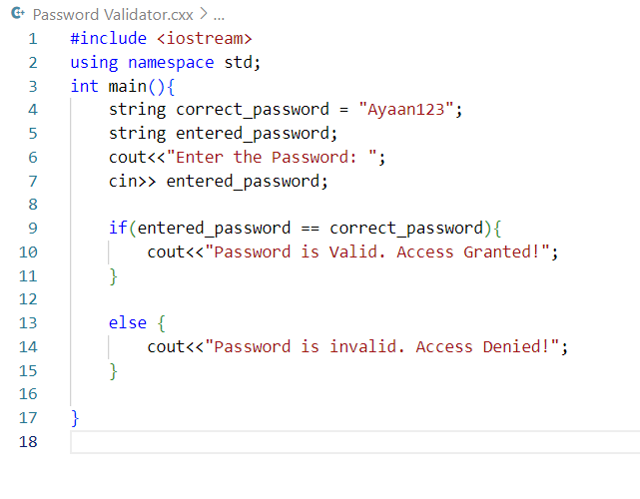**SOURCE CODE:**

**OUTPUT:**

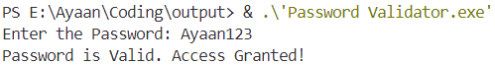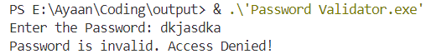

# **CODE # 9: Discount Calculator**

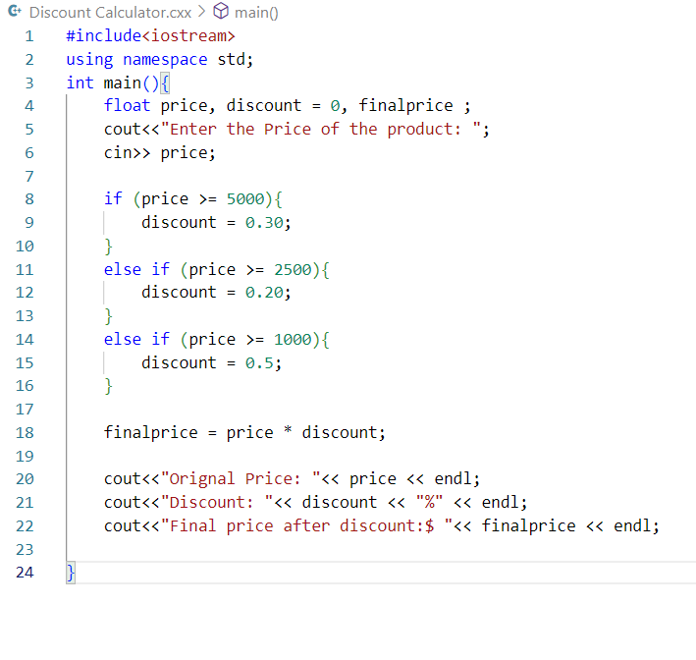**SOURCE CODE:**

**OUTPUT:**

# **CODE # 10: Number Range Checker**

**SOURCE CODE:**

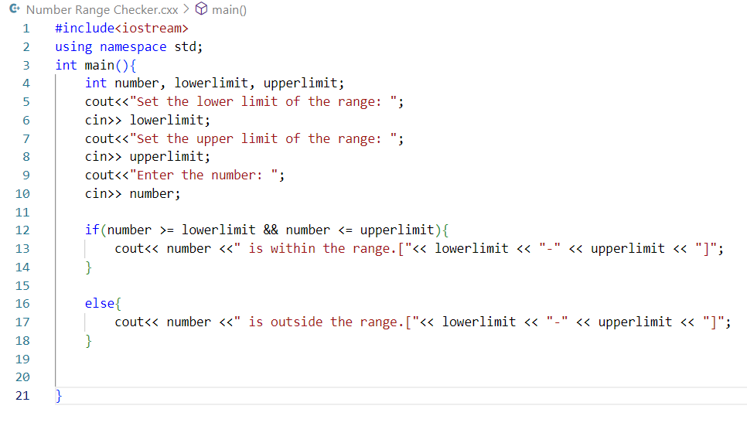

**OUTPUT:**

